Roll No 168330158

Project by

**Vipin Kumar**

**(B.TECH CSE VIII SEMESTER)**

**Project Report**

**On**

**CONTENT MANAGEMENT SYSTEM**

Submitted as a part of course curriculum for the partial fulfillment of the degree of

**Bachelor of Technology**

**CSE**

**Submitted By**

**Vipin Kumar**

Roll No : **168330158**

**Submitted To**

**Mrs. Richa Mishra**

**Department of Computer Science and Technology**

***Dr. Shakunatala Misra National Rehabilitaion University, Mohan Road Lucknow***

**ACKNOWLEDGEMENT**

I owe my regards to the entire faculty of the department of computer science and information technology at **Dr. Shakuntala Misra National Rehabilitaion University** from where I have learnt the basis of Computer Science and whose informal discussion and able guidance was a light for me in the entire duration of this work and carry out a project on “**CONTENT MANAGEMENT SYSTEM”.**

I would also like to thank my teachers who worked with me and our combined efforts led to the completion of the project.

**Vipin Kumar**

**Table Of Contents**

1. Introduction
2. The System Development Life Cycle
3. System Analysis
4. System Requirements analysis
5. Abstract
6. Analysis of Project
7. Authentication of Users
8. Input Data Validation
9. Folder Structure of Project
10. Database of IndianCMS
11. Database Tables
12. Working of Project IndianCMS
    * + - Front Page For Users
        - Post Page For Users
        - Registration Page For Users
        - Login Section
        - Comment Section
        - Admin Section
        - View All Posts Section For Admin
        - Add New Post Section For Admin
        - View All Users Section For Admin
        - View All Comments Section For Admin

13.Hardware and Software Used

14.Bibliograpghy

**Introduction**

The very first step of developing any system is to study the whole existing system this is called the initial study, analysis and feasibility of the project is being done. Analysis is the detailed study of the various operations performed by the system and their relationship within and outside the system. In context to this project the data to be created and deployed on the website is done regularly and changes are carried out at short and regular intervals. Hence the need to maintain the regularity of creation and deployment of data is necessary to make work easier and comfortable.

The feasibility study is carried out to select the best process that meets the performance requirements. This entails identification, description and evaluation of the CMS process and the selection of the best process(tool) for the job. Now according to this project the analysis is to have the complete knowledge about how the software that is going to develop is going to function. From where is the data going to come and what will be the output vs what is the required output. Once analysis is done or completed the analyst has the firm knowledge of what is to be done. The next step is to decide how the problem might be solved. Thus, in systems design, we move from the logical to the physical aspects of the life cycle.

So the conclusion of the initial study is that instead of going through various HTML pages to make updates and entries , a tool should be made to make all these changes and updation of the data on the website.This will be able to serve its clients and consumers more efficiently and in a satisfactory manner, also, this type of system will save lot of tremendous time, energy, tiring and repetitive work.

**Existing System**

As stated earlier in the introduction to the project, A website is a web page or a collection of interrelated web pages that convey some common theme or sell a particular business. These web pages are made with the help of scripting tools and languages. The web pages are often made very designer, colorful, and catchy in order to popularize business better. Good web design is a very important feature of a good website.At present scenario the usage of websites for business is growing organically with time and while it is useful it is very far from perfect.Much of the content is out-of-date or inaccurate, it’s hard to find things, updating the site is complex, and the appearance is becoming outdated. The person responsible for the creation of content and updation faces loads of problems to make changes as he needs to through all the pages to verify the data and create updations. Due to manual updations of data the updates are piling and updates are delayed.A track of all the data created and posted on websites is difficult to maintain.This is process is maximum times tedious, time consuming and leads to redundancy of data.manual.The various information related to the contents of the website is entered in the form of HTML pages. The Authenticates person is unable to keep with the pace of the increasing demands and usage of the Websites. The office currently operates under a semi- manual system of filing and retrieving documentation. These documents prepared with the usage of basic web designing languages and text editors.

In the Traditional system, searching for some specific information is the time consuming exercise. A number of pages and documents are being maintained. Proper upkeep of the documents is very difficult, as only the concerned person know where the desired information is available. The system is highly resource intensive as well as prone to errors. Piles of documents are there as new additions to these existing piles are occurring as time passes.

There major areas in which the Traditional system affects the cost are:

* + Slow retrieval time.
  + The system is single person intensive.
  + The Traditional system produces a risk of missing files which causes improper and redundant updates.
  + There is a lack of confidentiality.
  + No back up to support disaster recovery.
  + Posting of content and maintaing dates and updations is difficult.
  + Slow retrieval of webpages on the websites.
  + Complex and no specific manner to manage content.

**Proposed System**

A content management system (CMS) is a computer application used to create, edit, manage, search and publish various kinds of digital media and electronic text.

CMS is frequently used for storing, controlling, versioning, and publishing industry-specific documentation such as news articles, operators' manuals, technical manuals, sales guides, and marketing brochures. The content managed may include computer files, image media, audio files, video files, electronic documents, and Web content. These concepts represent integrated and interdependent layers.

Content management system an attempt to take a step towards “Integrated work”. Content management system a multi-user, user friendly and GUI based application.

In this system every authorised person will need to have computer terminals, which are attached to the server. All the data and content are kept on authenticated locations. Any query related to the posting of the data will be served from the centralized database server .This Login and Password should be kept confidential as this can provide access to each and every module of the website. Thus, system ensures the security from the unauthorized access other than the authorised people of the company.The system offers the functionality at client/server.

**Salient Features of Proposed System:**

* + User friendly.
  + Providing protection to data, through password.
  + Efficient retrieval of information.
  + Ensure accuracy of data, with in-built validations and checks.
  + Efficient linkage of information.
  + Informative reports.
  + Elimination of tedious works to a great extent.
  + Streamlined authoring process
  + Faster turnaround time for new pages and changes
  + Greater consistency
  + Improved site navigation
  + Increased site flexibility
  + Support for decentralized authoring
  + Increased security
  + Reduced duplication of information
  + Greater capacity for growth
  + Reduced site maintenance costs

**THE SYSTEM DEVELOPMENT LIFE CYCLE**

The System Development Life Cycle is an organized way to build an information system. The System Analysis and Design are keyed to the system life cycle .

The stages of the system development life cycle are:-

**1. RECOGNITION OF THE NEED:-**

One must know what the problem is before it can be solved. The basis of a system is recognition of need for improving an information system or procedure. This need leads to a prim nary survey or an initial investigation to determine whether an alternative system can solve the problem.

**2. FEASIBILITY STUDY:-**

Depending on the result of the initial investigation, the survey is expanded to more detailed feasibility study. A feasibility study is a test of the system proposal according to its workability impact on the organization, ability to meet user needs and effective use of recourses.

It focuses on three major questions:

* What are the user’s demonstrable needs and does a system meet them?
* What recourses are available for concerned person? Is the problem worth solving?
* What is the likely impact of the system organization?

The result of the feasibility study is a formal proposal. This is a report, a formal document detailing the nature and scope of the Proposed system.

**3. ANALYSIS:-**

Analysis is the detailed study of the various operations performed by the system and its relationships within and outside the system. The analyst collects unstructured data through different means of analysis. The interview is the commonly used tool in the system analysis. It requires special skills and sensitivity to the subject being interviewed. Training experience, common senses are required for the collection of information needed to do the analysis.

**4. DESIGN:-**

The term design describes a final system and the process by which it is developed. It includes the construction of the program and the program testing. The first aim is to determine how the output is to be determined and in what format. Second the input data master databases have to be designed to meet the requirements of the proposed output. The final report prior to implementation phase includes procedural flowcharts,record layouts and a workable plan for the implementation of the candidate system .

**5. IMPLEMENTATION:-**

It is primarily concerned with the user’s training, site preparation and file conservation. During the final testing user acceptance followed by the user training is tested. Once the programs become available the test data is fed into the computer and processed against the database files of the candidate system.

**6. SYSTEM TESTING:-**

System testing checks the readiness and accuracy of the system to access, update and retrieved data from new files. Once the programs become available test data are read into the computer and processed against the file provided for testing. If the testing is successful, the program is then run with the actual data otherwise a diagnostic procedure is used to locate and correct errors in the program.

**7.POST IMPLEMENTATION & MAINTENANCE:-**

After the implementation phase is completed the user staff is adjusted to the changes created by the candidate system evaluation and maintenance begins. This is an aging process that requires periodical maintenance of hardware and software. The importance of maintenance is to continue to bring the new system to standards. User priorities changes in organization requirements or environmental factors also call for system enhancements.

**SYSTEM ANALYSIS**

The System Analysis is the most important and critical processes for the development of an information system.. It means probing the problem and breaking it to several components so that a logical repackaging can evolve. Analysis is a detailed study of various operations performed by a system and their relationship within and outside the system. During analysis, details are collected on available files, decision points and transaction, on site observations and questionnaires are examples.

System analysis involves the fact finding of the problem, Information gathering and identification of constraints specific for system objectives and description of the outputs required for the concerned problem.

**1. RECOGNITION OF NEED**

One must know what the problem is before it can be solved. The basic for a candidate system is recognition of a need for improving an information system or a procedure.

**INITIAL INVESTIGATION:-**

The identification of need is done through initial investigation whose objective is to determine whether the request is valid and feasible before a recommendation is reached to improve or modify the existing system or build a new one. Once the need for a change is recognized, a preliminary survey or an initial investigation is projected to improve the existing system. It entails looking into the duplication of efforts, bottlenecks; inefficient existing system would be candidate for computerization. In large environments, where formal procedures are the norm, the analyst's first task is to prepare a statement specifying the scope and objective of the problem.

Problem must be identified before it can be solved. In this phase the study is done regarding the main reasons for the need of new system. In this context, the reasons are given that why the need of new program system has arisen.

The main reasons for this may be:

1.Internal reasons

2.External reasons

**1. INTERNAL REASONS:-**

The internal factors that leads to the need of a new system are within the organization itself. These internal reasons leading to the requirement of new system may be due to the Top Management .Presently, the file system is maintaining its data manually. So, the need is for a new and improved computerized system .If the Top Management decides to change the current traditional working system with an improved system, then the need for implementing the new system is due to internal reasons.

**2. EXTERNAL REASONS:-**

External reasons are those which leads to the implementation of a new system not just because of the organizational factors, but due to some external factors. The external reasons leading to a new system may be for providing better facilities to the customers and to increase the work ability and efficiency of the organization.

In order to enhance the work speed and efficiency, the organization may opt for the new system as it is quite fast in processing , more reliable, efficient and versatile. To meet the customer’s requirements, the organization may implement the proposed system so as to ensure the customer with better, fast and error free output from the organization. It adds to the goodwill and status of the organisation.

**SYSTEM REQUIREMENT ANALYSIS**

Prior to the software development efforts in any type of system it is very essential to understand the requirements of the systems and users. A complete specification of the software is the 1st step in the analysis of system. Requirements analysis provides the designer with the representation of functions and procedures that can be translated into data, architecture and procedural design.

The goal of requirement analysis is to find out how the current system is working and if there are any areas where improvement is necessary and possible. This may result in using alternative ways to data capturing and processing.

**INTERFACE REQUIREMENT**

**1.User Interface**

The package must be user friendly and robust. It must prompt the user with proper message boxes to help them perform various actions and how to precede further the system must respond normally under any in out conditions and display proper message instead of turning up faults and errors.

**2.Hardware Specification**

|  |  |  |  |  |
| --- | --- | --- | --- | --- |
| **CPU** | **SPEED** | **RAM** | **HARD DISK** | **KEYBOARD** |
| Intel Pentium IV and above | 1.5GHz and more | 2 GB and above | 80 GB | 105 Keys |

**Software Specifications**

Software is a set of program, documents, and procedure, routines associated with computer system. Software is an essential complement to hardware. It is the computer programs which when “Content Management System” has been developed using various tools.

**Abstract**

**Project Name :** IndianCMS

**Institute :** DSMNRU, Mohan Road Lucknow

**Project Type :** Content Management System

This is Content management software, has various features of Wordpress to manage dynamic content which is changing at regular and fast intervals. Then the web interface allows users to manage it from anywhere using just a web browser and predefined authentication. The servers can be used to create content, manage content and post or deploy content on the website.

Administrators or mangers etc are able to access the database according to their privilege after authentication using passwords.The fast changing content is also managed.

**Analysis of Project**

**Project : IndianCMS**

IndianCMS is a free and open-source project**.** This project is based on PHP and MySQL. It is mainly designed to manage any content inside a website using GUI instead to coding. You can use it to create a various types of posts.

Don’t misunderstand it as a blogging platform. The salient features of this project can only be managed by users having admin privileges.

The main feature of IndianCMS is its versatility and feasibility to use. There is no use of coding and designing skills for creating a post. Even a non-technical person can also create a post with the help of IndianCMS easily.

The posts can typically include **text, photos, videos, animated GIFs**, and more other media. Posts can be accessed publicly or is made for private use, it entirely depends upon the admin.

# Features Of IndianCMS

## Admin Login

## User Login

## User Registration

## Creating pages or posts without logical skill

## Plugins to add functionality

## Free and Open-source platform

## Adding a page is very easy

## More secure

## Inserting Multimedia

## Mobile-Friendly

## Easy to use

**Authentication of Users**

**Access for Users**

## User Login

## User Registration

## User Search for getting any content

## Email Newsletter

**Access for Admin**

## Admin Login

## Block or Delete any user

## Authenticating users

## Adding new users

## Comments Approve

## Create Pages

## Create Posts

## Delete Posts or Pages

**Input Data and Validation of Project on IndianCMS**

Validations can be performed on the server side or on the client side ( web browser). The user input validation take place on the Server Side during a post back session is called Server Side Validation and the user input validation take place on the Client Side (web browser) is called Client Side Validation. If the user request requires server resources to validate the user input, you should use Server Side Validation. If the user request does not require any server resources to validate the input , you can use Client Side Validation.

**Server Side Validation**

In the Server Side Validation, the input submitted by the user is being sent to the server and validated using one of server side scripting languages such as ASP.Net, PHP etc. But here I have used PHP for server side validation. After the validation process on the Server Side, the feedback is sent back to the client by a new dynamically generated web page. It is better to validate user input on Server Side because you can protect against the malicious users, who can easily bypass your Client Side scripting language and submit dangerous input to the server.

**Client Side Validation**

In the Client Side Validation you can provide a better user experience by responding quickly at the browser level. When you perform a Client Side Validation, all the user inputs validated in the user's browser itself. Client Side validation does not require a round trip to the server, so the network traffic which will help your server perform better. This type of validation is done on the browser side using script languages such as JavaScript, VBScript or HTML5 attributes.

For example, if the user enter an invalid email format, you can show an error message immediately before the user move to the next field, so the user can correct every field before they submit the form.

Mostly the Client Side Validation depends on the JavaScript Language, so if users turn JavaScript off, it can easily bypass and submit dangerous input to the server . So the Client Side Validation can not protect your application from malicious attacks on your server resources and databases.

As both the validation methods have their own significances, it is recommended that the Server side validation is more SECURE!

If a users don't enter any data or enter any invalid data format then they'll get messages such as:

* "This field is required" (You can't leave this field blank).
* "Please enter your phone number in the format xxx-xxxx" (A specific data format is required for it to be considered valid).
* "Please enter a valid email address" (the data you entered is not in the right format).
* "Your password needs to be between 8 and 30 characters long and contain one uppercase letter, one symbol, and a number." (A very specific data format is required for your data).

**Folder Structure of this Project**

**Database of IndianCMS**

A **database** is an organized collection of data, so that it can be easily accessed and managed.

You can organize data into tables, rows, columns, and index it to make it easier to find relevant information.

**Database handlers** create a database in such a way that only one set of software program provides access of data to all the users.

The **main purpose** of the database is to operate a large amount of information by storing, retrieving, and managing data.

There are many **dynamic websites** on the World Wide Web nowadays which are handled through databases. For example, a model that checks the availability of rooms in a hotel. It is an example of a dynamic website that uses a database.

There are many **databases available** like MySQL, Sybase, Oracle, MongoDB, Informix, PostgreSQL, SQL Server, etc.

Modern databases are managed by the database management system (DBMS).

**SQL** or Structured Query Language is used to operate on the data stored in a database. SQL depends on relational algebra and tuple relational calculus.

**RDBMS**

Here, In this project I have used RDBMS.

**RDBMS** stands for Relational Database Management Systems..

All modern database management systems like SQL, MS SQL Server, IBM DB2, ORACLE, My-SQL and Microsoft Access are based on RDBMS.

It is called Relational Data Base Management System (RDBMS) because it is based on relational model.

## **How it works?**

Data is represented in terms of tuples (rows) in RDBMS.

Relational database is most commonly used database. It contains number of tables and each table has its own primary key.

Due to a collection of organized set of tables, data can be accessed easily in RDBMS.

**Database Tables of this Project**

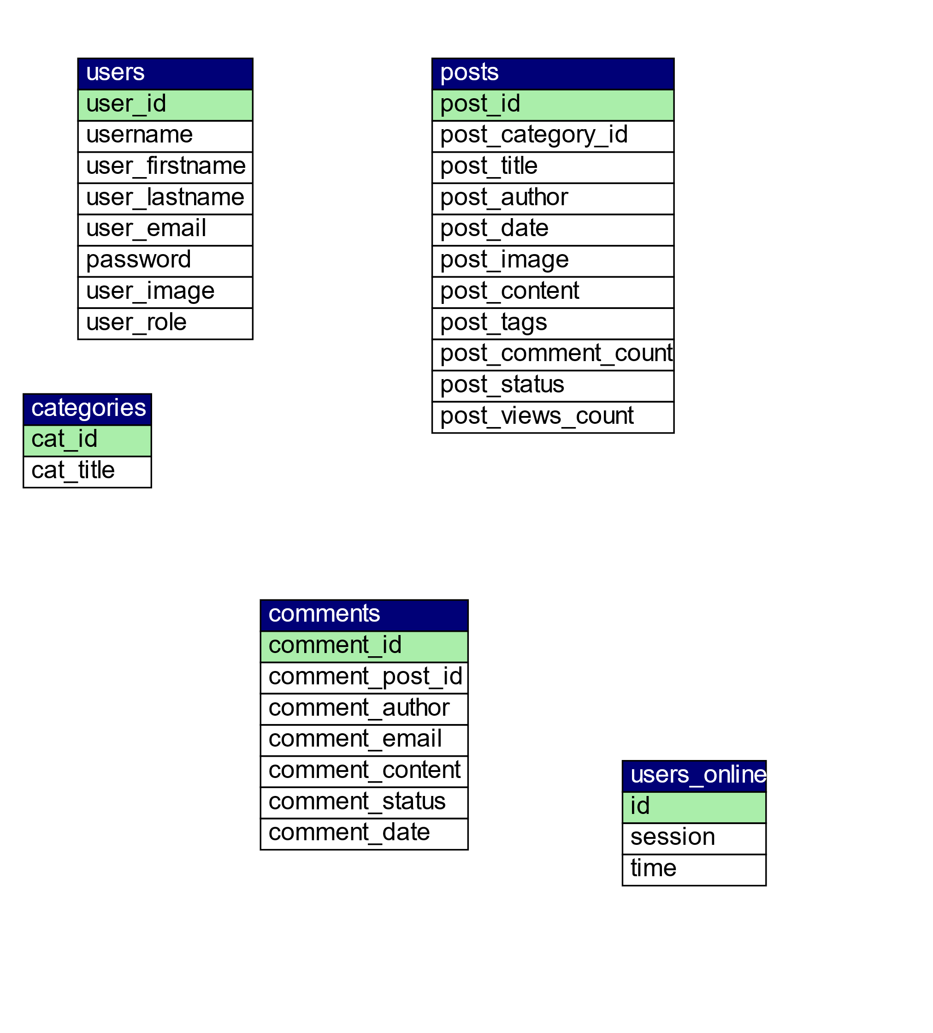

**Working of Project of IndianCMS**

***Some Important Sections***

**Front Page for Users**

* This is the front page when a user visits this website.
* A user can login or register. If user has admin previliges then after logging in he or she will be redirected to the admin page otherwise they will remain at the same page as a subscriber

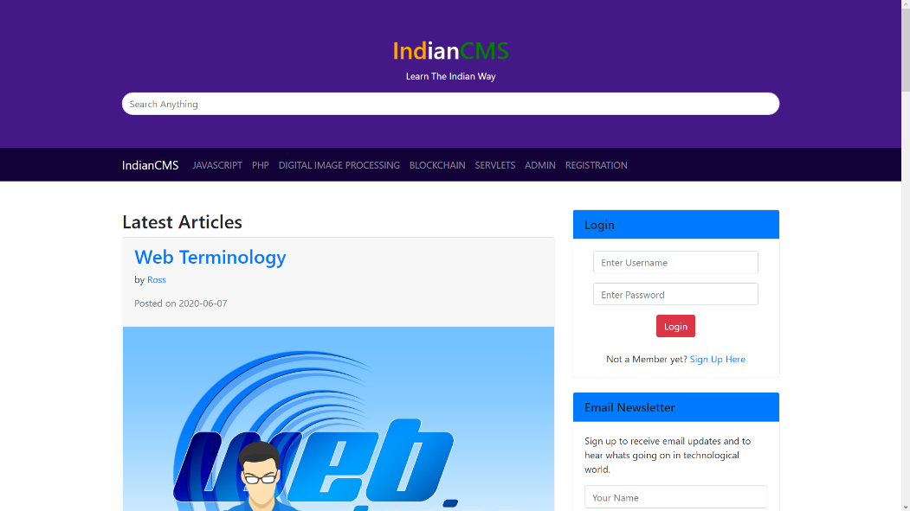

**Post Page For Users**

* If user clicks on any post they will be directed to this particular post.
* 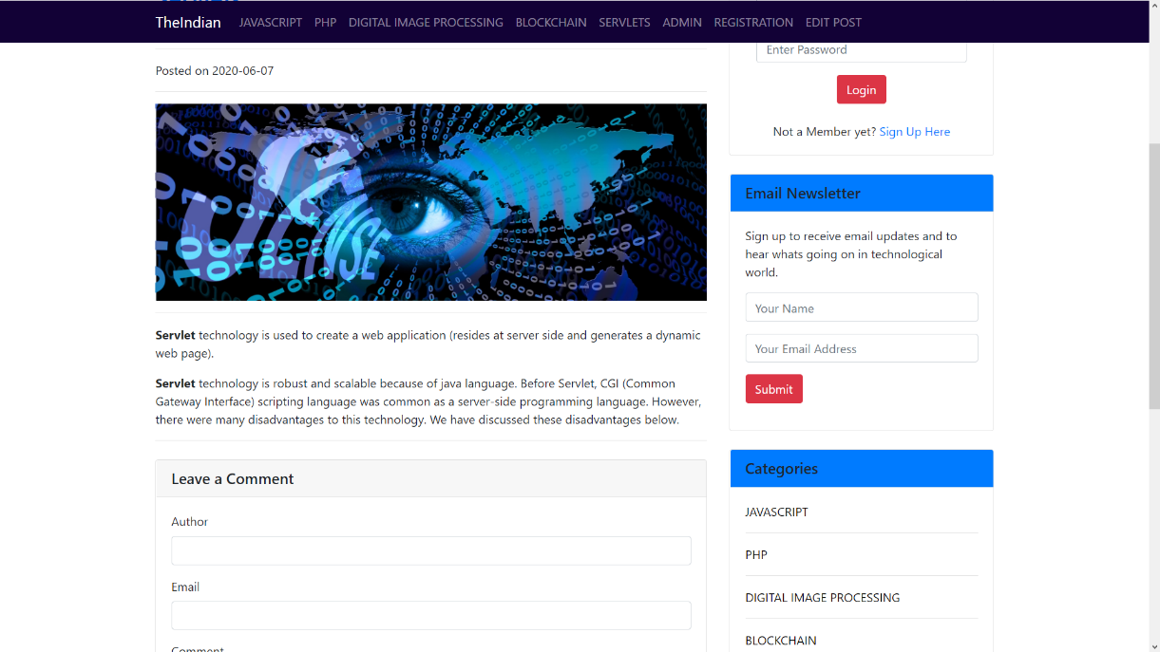User can click on author name to view all posts by a particular author or can also click on category to see all posts related that category.

**Registration Page For Users**

If a users don’t have any account then they may click on “Sign Up Here” link or Registration Button to access this page for creating free account.

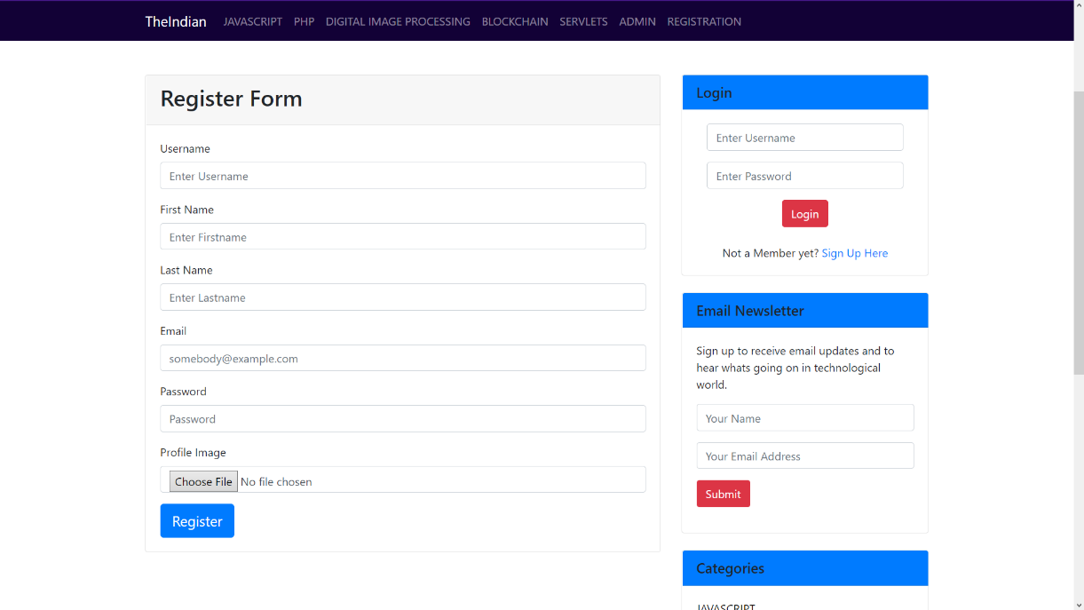

**Login Section**

* If a user already have an account then they can login by using their username and password.
* If they don’t have username and password then they wont be able to login.



**Comments Section**

* Any user can comment on any post but comments will be displayed below respective posts but only after the approval of the admin.

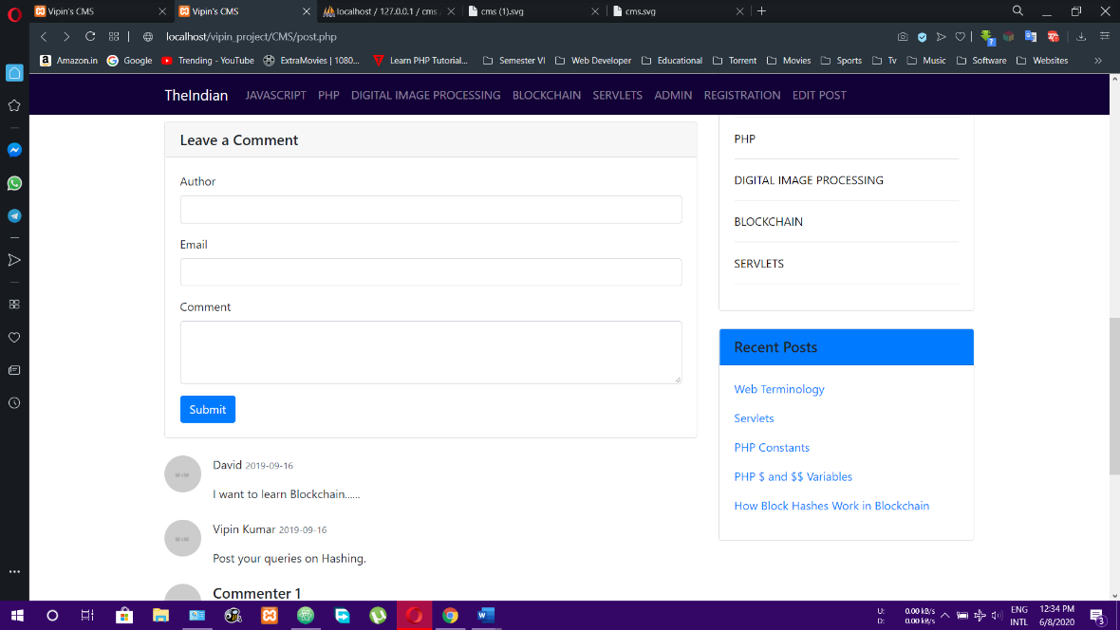

**Admin Section**

* User with admin previliges will be directed to this page as soon as they login.
* This admin section can only be accessed by users having admin privileges.
* 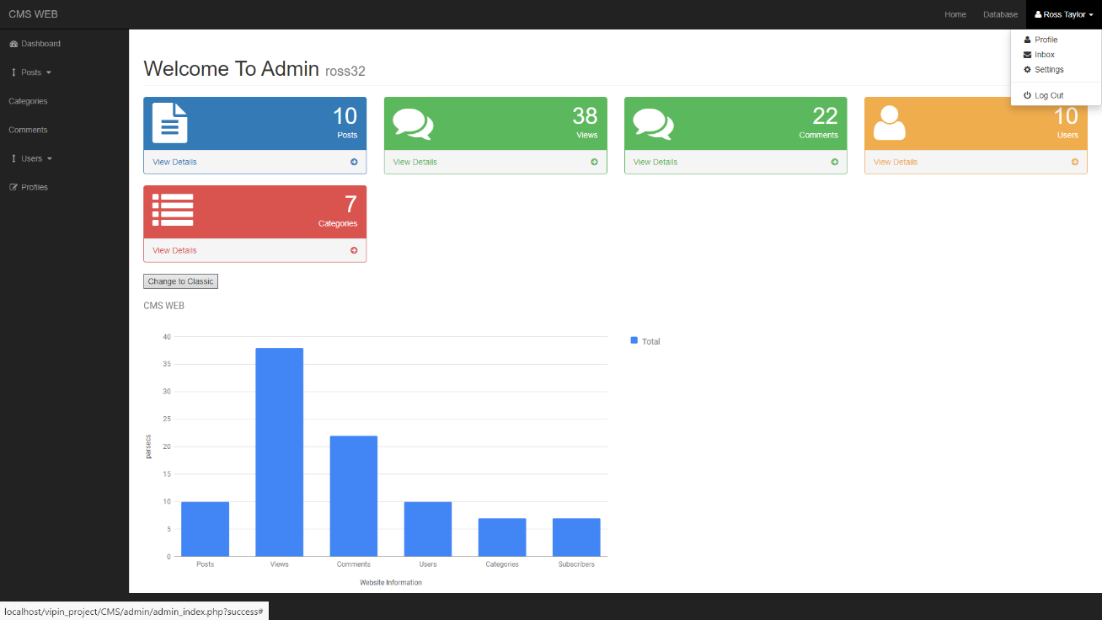If a subscriber user tries to access this page then he or she will be redirected to the main page of this website.

**Views All Posts Section For Admin**

* Click on views posts in the left section to view all posts.
* 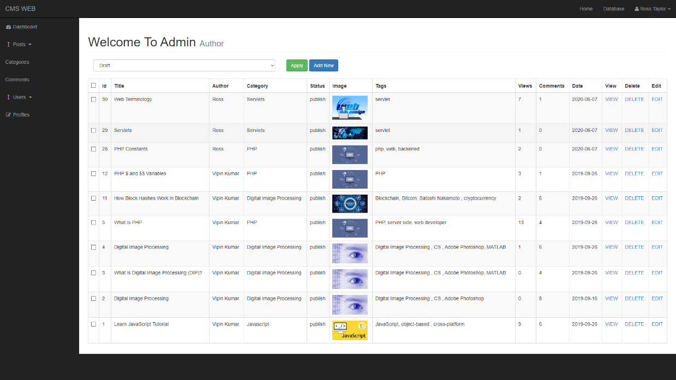Admin can now delete or edit any post.

**Add New Post Section For Admin**

* 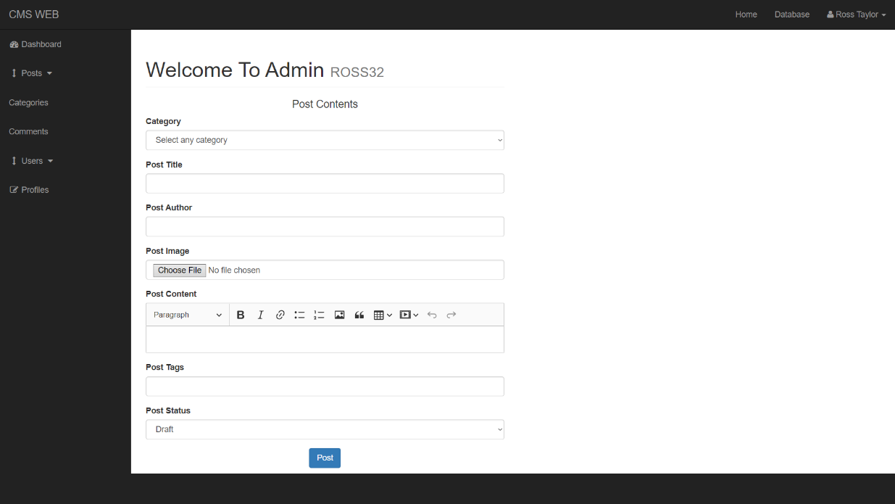To access this page click on add new button at the top of view all posts section to add any new post.

**View All Users Section For Admin**

* Click on views users in the left section to view all all users.
* Role of any user can be changed only by admin they can be made either subscriber or admin
* 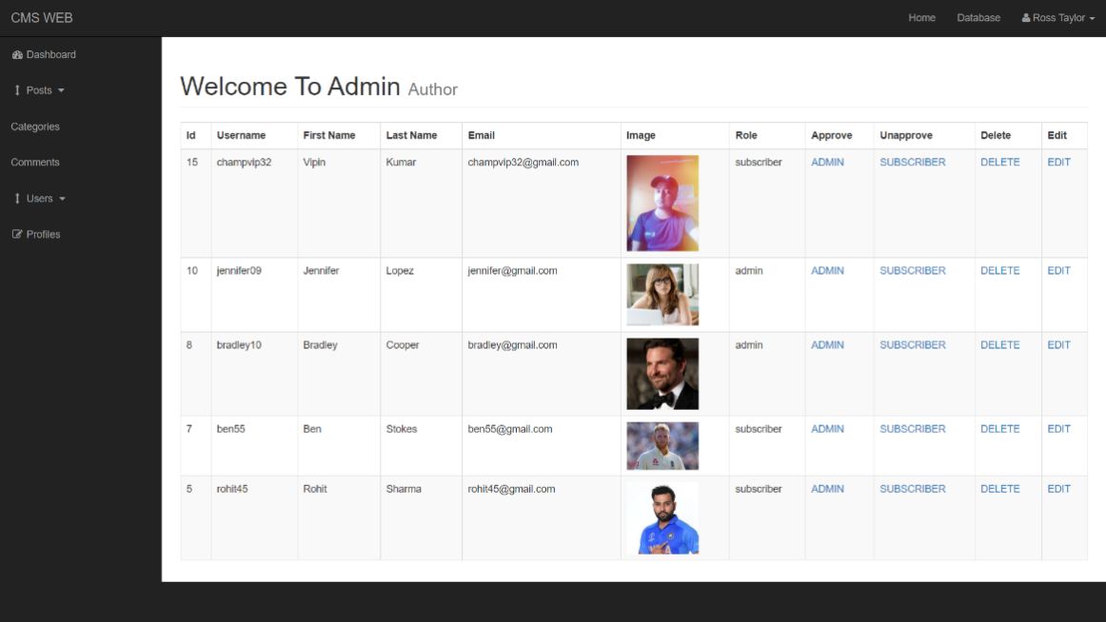Admin can delete or edit any user.

**View All Comments Section For Admin**

* Click on comments in the left section to view all comments.
* Admin can now approve or unapprove any comment to be displayed below any post in the website.
* Admin can also edit or delete any comment.
* 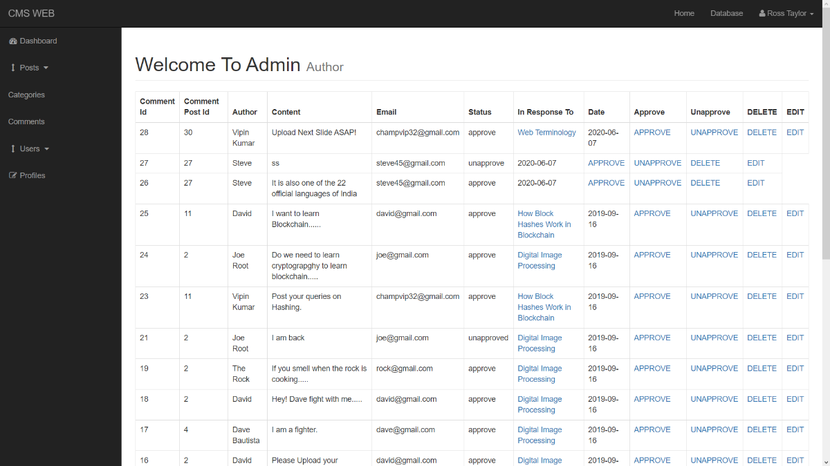Admin can directly visit to the post where the comments belongs fromthis page only.

**Hardware and Sofware Used**

**Sofware Used**

|  |  |
| --- | --- |
| **c** | Softwares |
| **OS** | **Windows 10** |
| **Browser** | Google Chrome, Opera |
| **Languages** | HTML, CSS, PHP, MySQL,JS |
| **Database** | MySql Server |
| **Web Server** | Tomcat |
| **Software** | Atom |

**Hardware Used**

|  |  |
| --- | --- |
|  | Hardwares |
| **CPU** | Intel(R) Core(TM) i5-7200U |
| **Speed** | 2.5 GHz |
| **RAM** | 8 GB |
| **Hard Disk** | 80 GB and More |
| **Keyboard** | 105 Keys |

**Bibliography**

1. [www.google.com](http://www.google.com)
2. [www.javatpoint.com](http://www.javatpoint.com)
3. [www.w3schools.com](http://www.w3schools.com)
4. PHP & MySql by Larry Ullman